Unit of Excellence Guide for Scouting America Crews
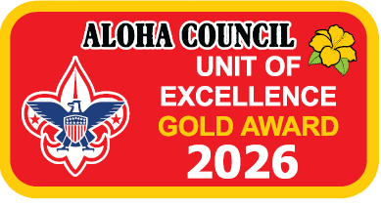
Unit of Excellence (UoE) Guidebook for Crews
A Tool to Help Your Crew and You Thrive
2026 Program Year

This guidebook was prepared as an assist to Crew leaders and others in using Unit of Excellence tools to plan and deliver excellent an excellent Venturing program.
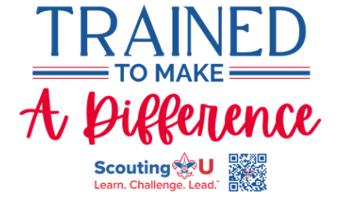.

UoE Guidebook for Scouting America Crews
A Tool to Help Your Crew and You Thrive
How to Use This Guidebook
This guidebook was created with busy Venturing Crew leadership in mind. It is intended to help the Crew Key 3—the Crew Advisor, Crew Committee Chair, and Chartered Organization Representative—along with youth officers and the Crew committee, use the Aloha Council Unit of Excellence (UoE) as both a program planning tool and a year-round checklist for delivering a high-quality, youth-led Venturing experience.
The Unit of Excellence replaces Scouting America’s Journey to Excellence while maintaining a familiar structure. It is designed to help Crews plan, evaluate, and continuously improve their program in areas such as youth leadership, adventure, advancement, service, adult training, and long-term sustainability. The UoE framework recognizes that Venturing success is driven by youth ownership and program relevance.
This guidebook draws from publications and resources available through Scouting America and Aloha Council and includes guidance on how to use those resources effectively. The Unit of Excellence incorporates and aligns many existing Scouting America programs and Venturing practices, some of which Crew leadership may not be fully familiar with. This guidebook explains what those programs are and how they connect to a successful Venturing Crew.
When used as intended, the information in this guidebook will help a Crew conduct an effective annual planning process, led by youth officers and supported by adult Advisors, that prepares the Crew for a year of meaningful adventure, leadership development, service, and fun.

This Guidebook Consists of (in Order)
- A summary sheet identifying a responsible youth officer or adult leader for each Unit of Excellence objective
- The 2026 Venturing Crew Unit of Excellence Scorecard, showing UoE objectives, measures, and performance levels
- The 2026 UoE Tracking Workbook/Spreadsheet, used as a planning checklist and progress-tracking tool
- Step-by-step guidance, presented in a suggested planning order, to help build a Venturing Crew program that delivers a high-quality experience while aligning with Unit of Excellence objectives

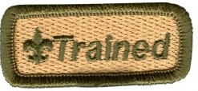
Adult leaders in units are considered “trained” and eligible to wear the official Trained emblem when they have completed Safeguarding Youth Training and the training courses outlined in the linked document below.
Listed below are a few Venturing on-line training modules providing further information on the what and how of each UoE objective. (See Objective #12, Trained Leadership)
Venturing Position Trained Requirements table-latest revision

Module SCO_112 - Annual Program Planning
Module SCO_107 - Event Planning
Leadership recruitment Module SCO_113 - Selecting Advisors

Outdoor activities - SCO_800 - Hazardous Weather Training
Advancement
- Module SCO_110 – Awards Program
- Module SCO_106 Board of Review

Progress Record Sheets for:
- Scouter’s Training Award for Venturing Leaders - latest revision
- Advisor’s Key- latest revision
- Venturing Leadership Award
- Unit Leader Award of Merit – latest revision
Crew budgeting information
- Crew Operating Budget Worksheet
- Unit Money-Earning Application

Leader Training
Leader training and recognition is extensively discussed in this guidebook and mentioned here. Providing leadership for Unit of Excellence objectives is an important part of having a successful unit. Please use the following summary sheet as a tool to guide the Crew adults in helping the Crew be the best it can be.

Venturing Crew Unit of Excellence Planning 2026 Summary Sheet
Crew:_____________________ District:____________________________
Unit of Excellence Overall Goal
- Bronze
- Silver
- Gold

This table lists all 14 UoE objectives in the order presented in the guidebook. For each objective list the responsible adult and circle the UoE goal the volunteer is helping the Crew achieve.
UoE Scoresheet Objective | # | Responsible Adult | Goal
 | 1 |  | B S G
 | 2 |  | B S G
 | 3 |  | B S G
 | 4 |  | B S G
 | 5 |  | B S G
 | 6 |  | B S G
 | 7 |  | B S G
 | 8 |  | B S G
 | 9 |  | B S G
 | 10 |  | B S G
 | 11 |  | B S G
 | 12 |  | B S G
 | 13 |  | B S G
 | 14 |  | B S G
 | 15 |  | B S G

____________________________ _________________
Advisor Date

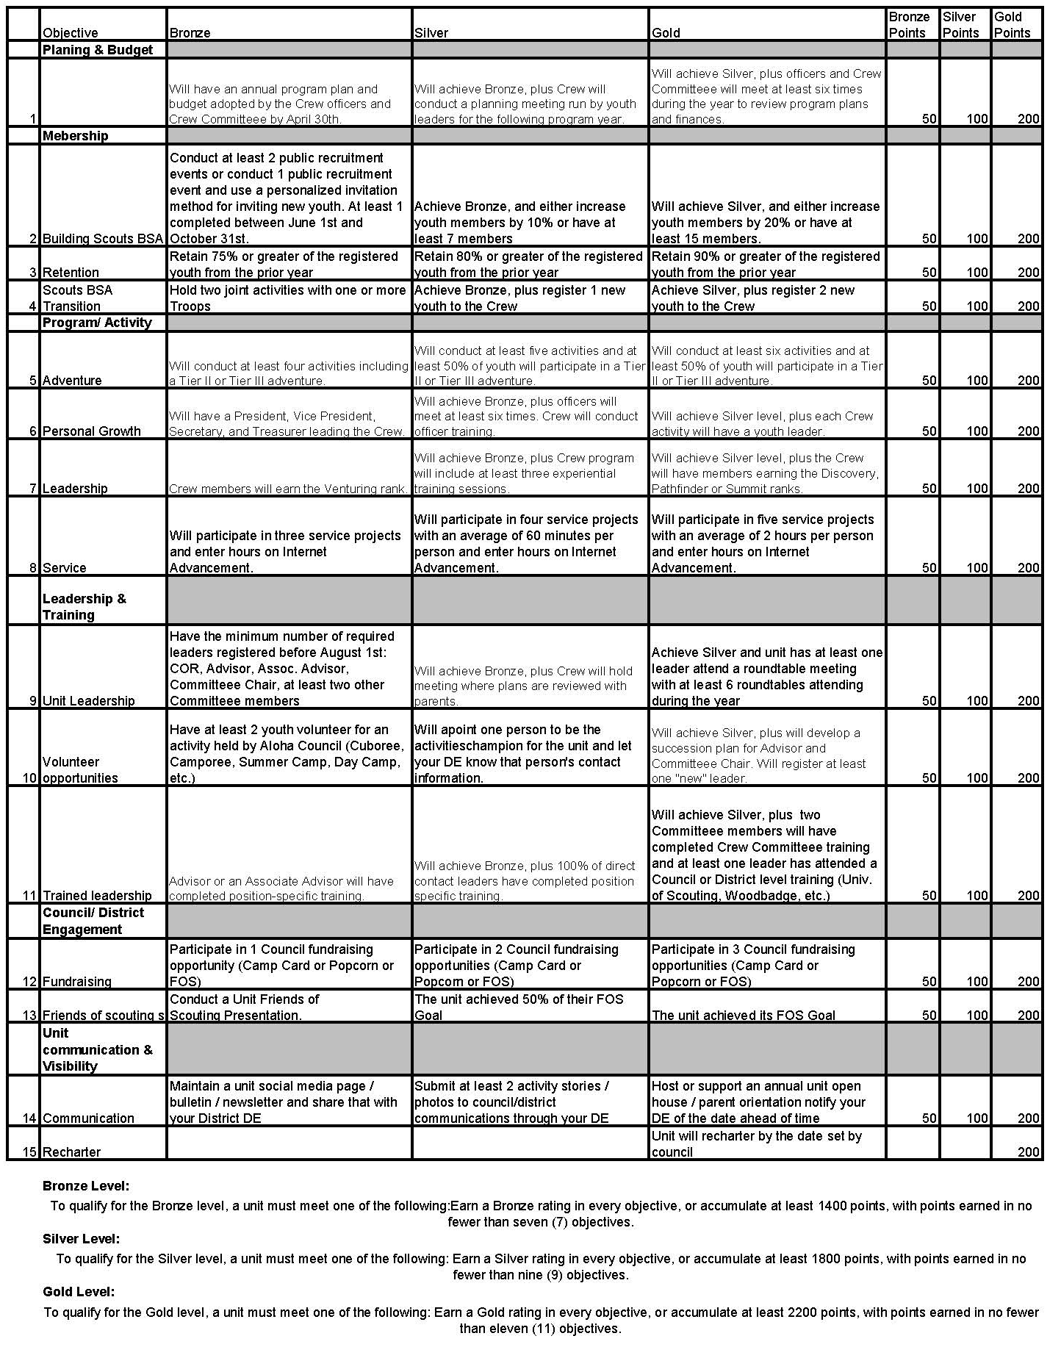
Aloha Council’s Unit of Excellence 2026 Crew Planning, Performance, and Recognition
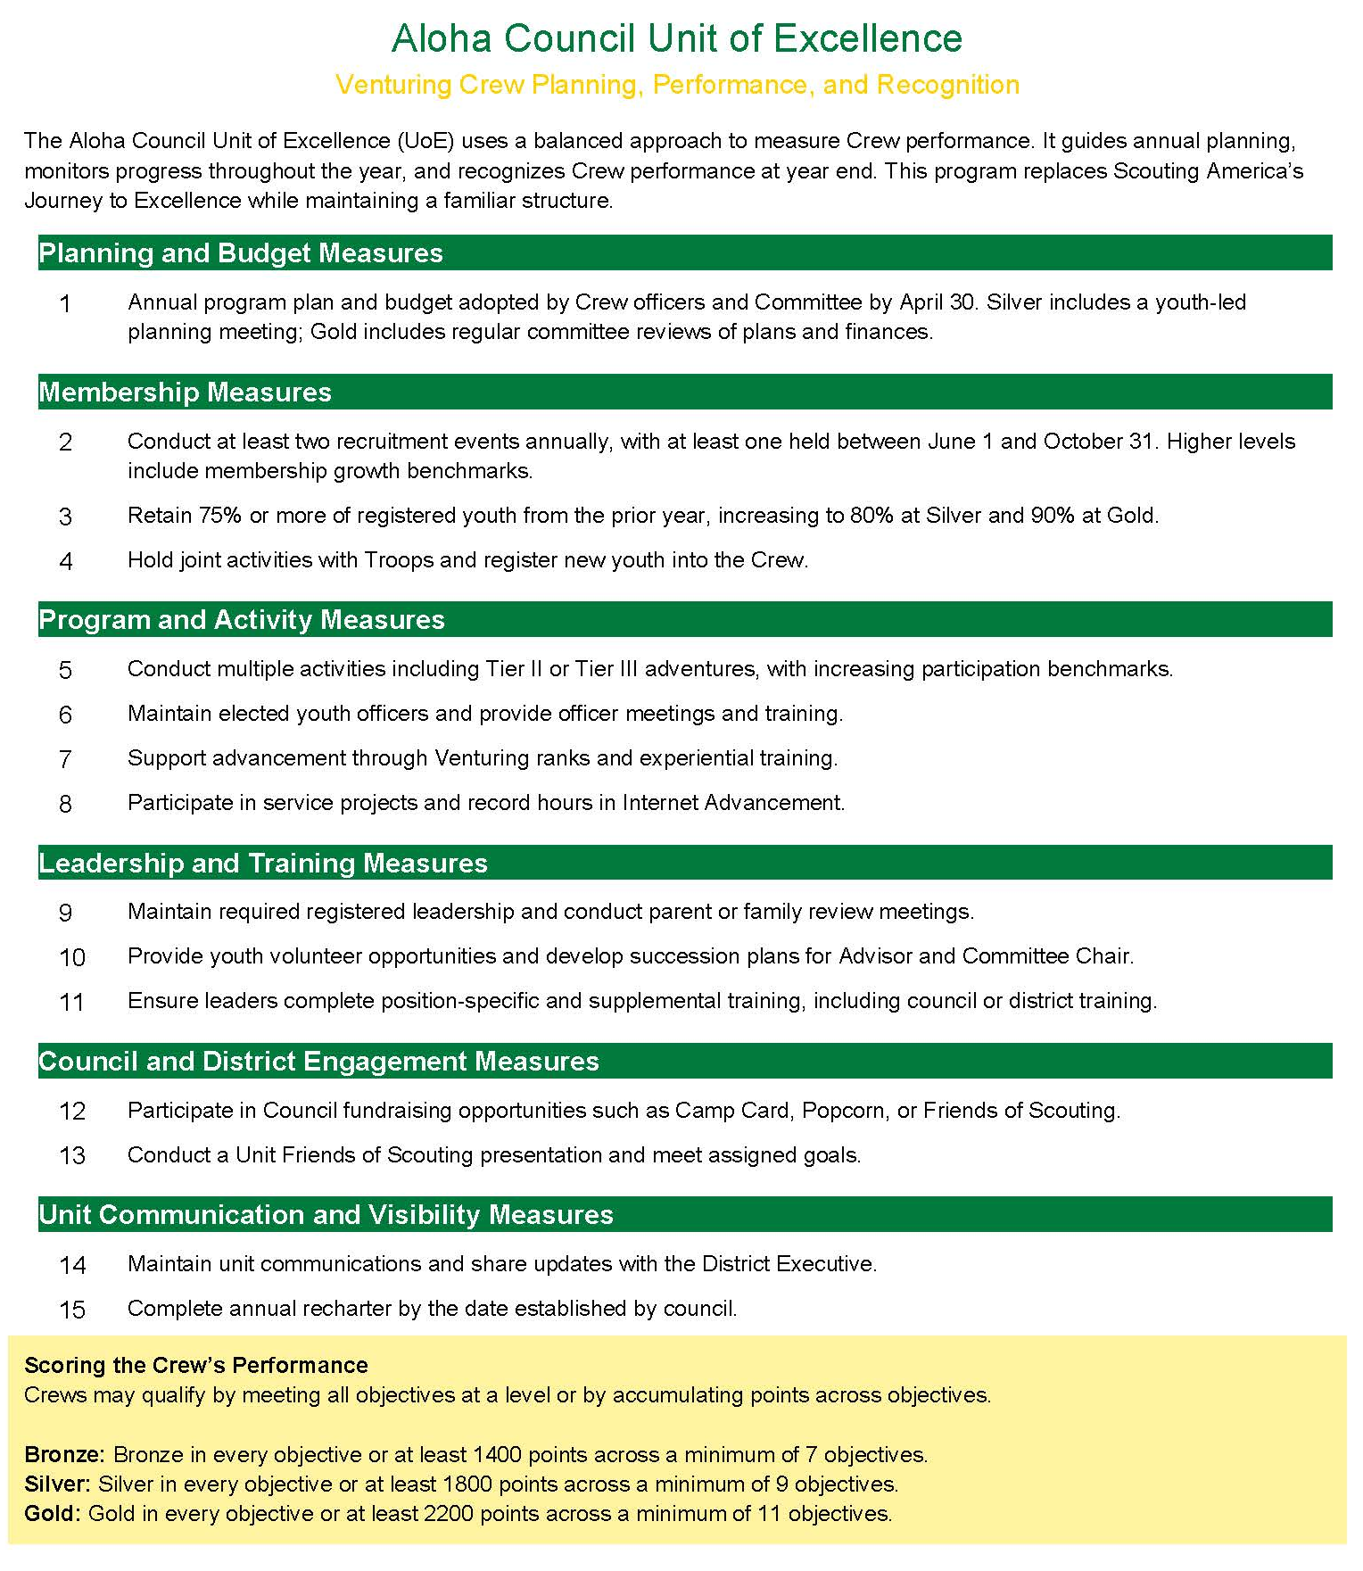
Planning for Success
Every Venturing Crew should have a regular and intentional planning process. A successful Crew is built through thoughtful planning of adventures, activities, service projects, leadership development, advancement opportunities, and finances.
Planning should be youth-led, with officers guiding the process and adult Advisors providing support. Crews may use calendars, planning sheets, or digital tools - the method is flexible as long as a clear plan exists and is shared.
Key Crew leadership should be involved, including:
- Crew President and Officers
- Advisor and Associate Advisors
- Crew Committee Chair and members
Commissioner Tip: Youth-Led Planning
What to look for:
Are Crew officers leading the planning process?
How to help:
Encourage officers to take ownership of program planning, with Advisors providing coaching rather than direction.

Commissioner Tip: Program Relevance
What to look for:
Is the Crew’s program aligned with current youth interests?
How to help:
Use UoE objectives to help officers evaluate whether activities remain adventurous, engaging, and relevant.

The Role of Commissioners
Crews are encouraged to involve their Unit Commissioner in the planning process. Commissioners help interpret Unit of Excellence objectives and connect Crews with district and council resources.
Commissioner Tip: Role of Commissioners
What to look for:
Are there District or Council Resources that would assist the crew with their goals?
How to help:
Look for upcoming activities and events that align with the goals of the youth of the crew.

Understanding the Unit of Excellence Objectives
Crew UoE objectives focus on:
- Planning and Budget
- Membership and Retention
- Adventure and Program Activities
- Leadership Development
- Advancement
- Service and Council Engagement
Bronze, Silver, and Gold levels recognize increasing depth of youth leadership, participation, and program quality.

Commissioner Tip: Understanding UoE Objectives
What to look for:
Are adult leaders setting goals without youth buy-in?
How to help:
Reinforce that Venturing success depends on youth ownership, which is reflected throughout the UoE objectives.

Using the UoE Scorecard and Tracking Tools
The Crew Unit of Excellence Scorecard summarizes each objective and its expectations. Additional explanation is provided through council materials and scorecard guidance.
A tracking worksheet or spreadsheet is available to help troops:
- Record planned activities
- Track progress throughout the year
- Calculate points and recognition level
Using the tracking tool during the planning session helps leadership clearly see what actions are needed to reach Bronze, Silver, or Gold.
Commissioner Tip: Leadership Development
What to look for:
Are Quarterdeck or officer meetings happening regularly?
How to help:
Encourage consistent officer meetings and leadership training to support Silver and Gold level expectations.

Before the Planning Session Begins
Before holding your annual planning session, it is helpful to:
- Confirm the meeting location and participants
- Gather school vacation schedules and holiday calendars
- Review district and council event dates
- Decide how the program calendar will be displayed
- Ensure the meeting space allows for discussion and collaboration
Preparation helps make the planning session efficient and productive.
Commissioner Tip: Before the Planning Session
What to look for:
Is the budget driving the program instead of supporting it?
How to help:
Remind leaders: Plan the program first, then build the budget to support it.

Where to Start? Objective #1 – Calendar and Budget
Objective #1 provides the roadmap for the Crew’s year. Youth leaders plan the program first, then develop the budget to support it.
Bronze requires a published plan adopted by the committee by April 30. Silver and Gold levels add youth-led planning and regular program and financial reviews.
Commissioner Tip: Objective #1 – Calendar and Budget
What to look for:
Is the budget driving the program instead of supporting it?
How to help:
Remind leaders: Plan the program first,
then build the budget to support it.
Commissioner Tip: Advancement
What to look for:
Are members unclear about Venturing advancement opportunities?
How to help:
Help Advisors connect advancement objectives to program planning rather than treating advancement as a separate activity.

Leadership, Recruitment, and Training – Objectives #10 and #11
Strong Crews plan ahead for leadership needs.
Volunteer Opportunities encourage Crews to identify tasks needed to deliver the program and provide families clear opportunities to help. As Crews progress to Silver and Gold, they recruit leaders earlier and develop succession plans for key roles such as Advisor and Associate Advisor.
Trained Leadership ensures leaders are prepared and confident. All registered adults must complete Safeguarding Youth Training before working with youth. Position-specific training and supplemental training through Scouting U, IOLS, University of Scouting, Woodbadge, and other courses strengthen the troop.
Training expectations increase at each level, reinforcing that trained leaders are essential to delivering a safe, youth-led, outdoor-focused Scouts BSA program.
Commissioner Tip: Adult Training and Succession
What to look for:
Is the Crew relying on one adult leader?
How to help:
Encourage succession planning and ongoing adult training to ensure long-term sustainability.

Putting It All Together
Used intentionally, the Unit of Excellence helps Crews:
- Deliver exciting, relevant programs
- Develop confident youth leaders
- Balance adventure, advancement, and service
- Sustain long-term success
Commissioner Tip: Putting It All Together
What to look for:
Is the Crew struggling with consistency?
How to help:
Use UoE as a stability and continuity tool,
especially during officer transitions.

Continued Training
Encourage Crew leadership—both youth officers and adult Advisors—to pursue ongoing training throughout the year. Continued training supports strong youth leadership, relevant programming, and sustained Crew success, directly supporting Unit of Excellence objectives.
Include District Roundtable or Venturing-specific Roundtable opportunities on the Crew calendar. These gatherings provide resources, networking, and program inspiration. Council and District training events, including University of Scouting, should also be identified and scheduled.
Adult Advisors and Committee Members are encouraged to engage with the District Training Team to expand access to training resources and support.

Adult Leader Training Awards – Venturing
Venturing adult leaders are encouraged to work toward earning the Scouter’s Training Award for Venturing. This award recognizes leaders who demonstrate commitment to training, youth leadership, and program delivery.
Current requirements include:
- Registration and required tenure as a Venturing Advisor or Associate Advisor
- Completion of Safeguarding Youth Training and position-specific training
- Active involvement in Crew planning and program support
- Participation in supplemental training opportunities
Leaders pursuing this award should support at least one Crew Unit of Excellence objective, such as adventure planning, leadership development, advancement, service, or membership growth.

Unit Leader Award of Merit – Advisor
Crew Advisors may be nominated for the Unit Leader Award of Merit, recognizing excellence in unit leadership and program quality.
Eligibility includes:
- Current registration as a Crew Advisor
- Required tenure and training completion
- Demonstrated success in youth-led planning, advancement support, and Crew sustainability

Advanced Venturing Training
Adult leaders are encouraged to complete:
- Venturing Leader-Specific Training
- Powder Horn (high-adventure resource training)
- Wood Badge for advanced leadership development
Training dates should be incorporated into the Crew’s annual plan.

Outdoor Fun!
Unit of Excellence Objectives: Adventure, Program, Leadership, and Service
Adventure is the heart of the Venturing program and should be youth-designed and youth-led. Outdoor and adventure activities support multiple Unit of Excellence (UoE) objectives and keep the Crew relevant, engaging, and exciting.
Adventure and Program Activities
Crews should plan a program that includes adventurous activities, such as:
- Outdoor adventure trips
- High-adventure experiences
- Skill-based outings
- Super activities or long-term adventures
During the annual planning process, Crew officers should select activities that reflect the interests of the youth while balancing adventure, advancement, leadership development, and safety.
Dates for council and district Venturing activities should be placed on the Crew calendar and shared with members and families.

Crew Activities and Engagement
In addition to major adventures, Crews should plan regular activities that maintain momentum and engagement. These may include:
- Skills training
- Social or team-building events
- Joint activities with other Crews or units
Consistent participation and varied programming support retention and higher levels of Unit of Excellence performance.

Service Projects
Service is an important part of Venturing and should be intentionally planned. Crews should schedule multiple service projects and encourage meaningful participation by members.
Service projects may include:
- Community service initiatives
- Conservation projects
- Support for council or district events
Service hours must be recorded in Scoutbook Plus.
Increasing participation and leadership in service projects supports Unit of Excellence objectives and Venturing advancement.

Coordinating Adventure and Service
Assign a youth officer or adult Advisor to coordinate adventure and service activities. This role supports:
- Program organization
- Communication and logistics
- Accurate tracking of participation and service hours
Leadership in this role supports advancement and adult training recognition while strengthening Crew sustainability.

Putting It All Together
Intentional adventure planning helps Crews:
- Deliver exciting, youth-driven programs
- Retain members through meaningful experiences
- Develop confident youth leaders
- Achieve higher Unit of Excellence recognition
Adventure doesn’t happen by accident—it happens through youth leadership and planning.

Recruiting & Sustaining Crew Membership - UoE Objective #2
Venturing Crews thrive when they actively recruit and retain members who are excited about adventure and leadership.
Recruiting strategies may include:
- Open adventure events
- Peer-to-peer invitations
- Joint activities with other units
- Community or school outreach
Crew Officers, supported by the Advisor and Committee, should take the lead in recruiting and welcoming new members.

Transition & Growth Opportunities - UoE Objective #4
Crews should actively engage:
- Scouts BSA members who are aging out
- Youth seeking high-adventure and leadership opportunities
Joint activities with Troops provide natural transition pathways and strengthen unit relationships.

Crew Planning and Budget - UoE Objective #1
A successful Crew program is youth-designed and youth-led.
Crew Officers should:
- Conduct an annual planning meeting
- Build a program calendar reflecting member interests
- Develop a budget that supports planned adventures
The Crew Committee should review plans and finances regularly.

Adventure & Advancement - UoE Objectives #5–#7
Adventure is the core of Venturing.
Crews demonstrate excellence by:
- Offering challenging, relevant activities
- Supporting Venturing advancement
- Encouraging leadership development
Participation and advancement should be tracked in Scoutbook Plus.

Retention Through Meaningful Experiences - UoE Objective #3
Venturers stay when activities are exciting, leadership is real, and the program is relevant to their interests.

