Unit of Excellence Guide for Packs
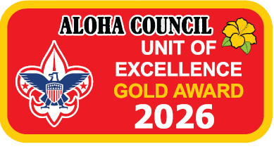
Unit of Excellence (UoE) Guidebook for Cub Scout Packs
A Tool to Help Your Pack and You Thrive
2026 Program Year

This guidebook was prepared as an assist to Cub Scout pack leaders and others in using Unit of Excellence tools to plan and deliver excellent Cub Scouting through Cub Scout packs and dens.
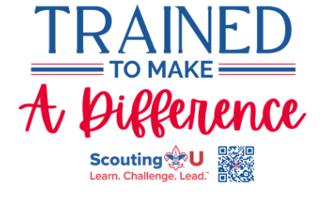

UoE Guidebook for Cub Scout Packs
A Tool to Help your Pack and You Thrive
How to use this Guidebook?
This guidebook was created with busy Cub Scout pack leadership in mind. It is intended to help the pack key 3, the committee chair, the Cubmaster and the chartered organization representative in using the Unit of Excellence (UoE) concept as a unit planning tool and year-round checklist of fun activities for the Cub Scouts.
This guidebook was made from various publications and documents available from the National Council and Aloha Council websites and includes instructions on how to use them.
Unit of Excellence uses and blends many existing Scouting America programs, some of which the unit leadership may not be familiar with. The material in this guidebook should answer what these programs are.
The information in the guidebook should enable the Cub Scout pack committee to conduct a pack planning session that prepares the pack for a very successful year of fun.
This Guidebook consists of (in order)
- A summary sheet used to show a responsible adult for each of the UoE objectives
- The 2026 UoE Scorecards that show UoE measures and levels
- The 2026 UoE Tracking Workbook/Spreadsheet to use as a planning checklist
- Instructions, provided in a suggested planning order, to use in building pack activities that provide great Cub Scouting connected to the UoE objectives.

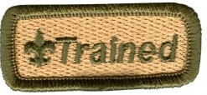
Adult leaders in units are considered “trained” and eligible to wear the official Trained emblem when they have completed Safeguarding Youth Training and the training courses outlined in the linked document below.
Listed below are a few Cub Scouting on-line training modules providing further information on the what and how of each UoE objective. (See Objective #12, Trained Leadership)
Cub Scout Pack Leader Position Trained Requirements table-latest revision

Planning the program year Module SCO_468 - Annual Program Planning
Pack and den meetings
- Module SCO_458 - Conducting A Cub Scout Pack Meeting
- Module SCO_455 - Conducting A Cub Scout Den Meeting
Leadership recruitment Module SCO_462 - Involving Adults In Cub Scouting
Outdoor activities
- Module SCO_420 – Preparing Families for Outdoor Activities
- Module SCO_461 – Keeping Cub Scouting Safe
- SCO_800 Hazardous Weather Training
Budget Module SCO_467 – Pack Finance
Advancement Module SCO_453 - Advancement

Progress Record Sheets for:
- Scouter’s Training Award for Cub Scouting-latest revision
- Den Leader Training Award-latest revision
- Cubmaster Key-latest revision
- Unit Leader Award of Merit
Pack budgeting information
- Pack Budget Worksheet
- Unit Money-Earning Application
Leader Training
Leader training and recognition is extensively discussed in this guidebook and mentioned here. Providing leadership for Unit of Excellence objectives is an important part of having a successful unit. Please use the following summary sheet as a tool to guide the Cub Scout pack adults in helping the pack be the best pack it can be.
Cub Scout Pack Unit of Excellence Planning 2026 Summary Sheet
Pack:_____________________ District:____________________________
Unit of Excellence Overall Goal
- Bronze
- Silver
- Gold

This table lists all 16 UoE objectives in the order presented in the guidebook. For each objective list the responsible adult and circle the UoE goal the Scouter is helping the Pack achieve.
UoE Scoresheet Objective | # | Responsible Adult | Goal
 | 1 |  | B S G
 | 2 |  | B S G
 | 3 |  | B S G
 | 4 |  | B S G
 | 5 |  | B S G
 | 6 |  | B S G
 | 7 |  | B S G
 | 8 |  | B S G
 | 9 |  | B S G
 | 10 |  | B S G
 | 11 |  | B S G
 | 12 |  | B S G
 | 13 |  | B S G
 | 14 |  | B S G
 | 15 |  | B S G
 | 16 |  | B S G
 | 17 |  | B S G

____________________________ _________________
Committee Chair Date
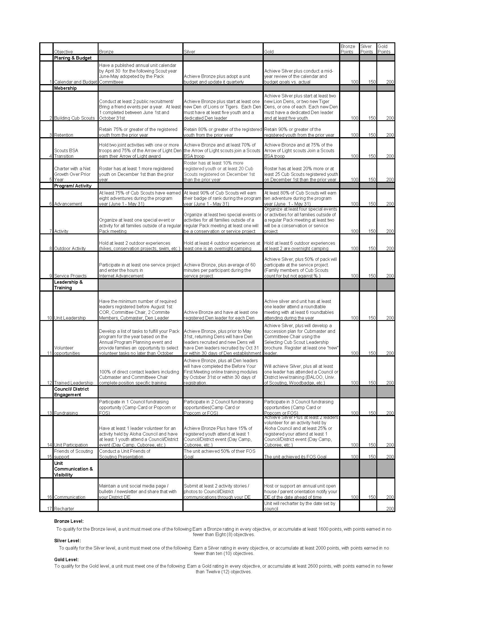
Aloha Council’s Unit of Excellence
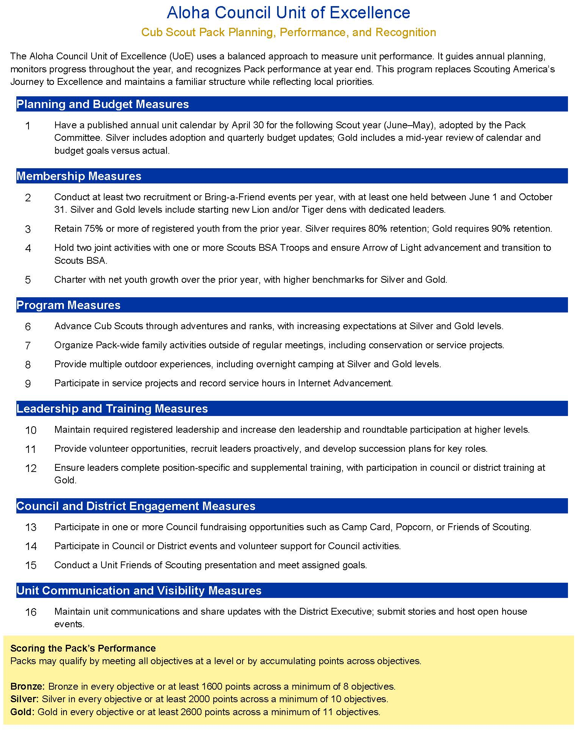
2026 Pack Planning, Performance, and Recognition
Planning for Success
Every Cub Scout pack should have a regular and intentional planning process. A successful pack does not happen by accident; it is built through thoughtful planning of meetings, activities, service projects, outdoor experiences, and fundraisers.
There are many effective ways to plan. Scouting America continues to provide guidance through online training modules and planning tools, including resources related to Annual Program Planning. Packs may use a large wall calendar, a year-at-a-glance planning sheet, or individual monthly planning pages. The method is flexible—the important part is that a plan exists and is shared.
Key pack leadership should be involved in the planning process, including:
- The Cubmaster
- Pack Committee Chair
- Chartered Organization Representative
- Pack Treasurer
- Den Leaders
- Parents supporting advancement, membership, fundraising, and activities
While the structure is flexible, every pack needs a clear way to plan its program year.
Commissioner Tip: Planning for Success
What to look for:
Does the Pack have a written calendar
adopted by April 30th and shared with families?
How to help:
Offer to review the draft calendar, check for balance (outdoor activities, service, family events),
and confirm it aligns with district and council dates.

The Role of Commissioners
Packs are strongly encouraged to involve their Unit Commissioner in the planning process. Commissioners are experienced Scouters whose role is to help units succeed.
Let your Unit Commissioner know when your Pack is holding its planning session and invite them to attend. Commissioners can help interpret the Unit of Excellence objectives, answer questions, and connect packs with district or council resources. If you are unsure who your Unit Commissioner is, or do not believe you have one assigned to your unit, ask at Roundtable or contact your District Executive.
Commissioner Tip: Youth and Family Engagement
What to look for:
Are parents clearly informed of expectations and volunteer opportunities early in the year?
How to help:
Encourage the Pack to distribute the annual calendar and budget to families and use it as a tool for recruiting volunteers.
.

Understanding the Unit of Excellence Objectives
Each Cub Scout Pack Unit of Excellence scorecard is organized into objectives, grouped by focus areas such as:
- Planning and Budget
- Membership
- Program and Activities
- Leadership and Training
- Council and District Engagement
- Communication and Visibility
Each objective includes three performance levels:
- Bronze – Effective
- Silver – Strong
- Gold – Exceptional
These levels help Pack leadership decide where to place emphasis during the planning process. Some objectives may be more important to your chartered organization or families than others, and the UoE framework allows flexibility while still encouraging balanced growth.
Points are assigned to each objective based on the level achieved. Packs may earn recognition in one of two ways:
- By earning the same level (Bronze, Silver, or Gold) in every objective, or
- By earning a minimum number of points across a minimum number of objectives
Every Cub Scout pack should strive to be a Gold Pack, but the system is designed to recognize improvement and success at all levels.
What to look for:
Is the Pack overwhelmed by trying to “do everything” at once?
How to help:
Remind leaders they can earn recognition by being well-rounded across objectives or by excelling in multiple focus areas. Help them identify which objectives best match their Pack’s strengths.

Using the UoE Scorecard and Tracking Tools
The Pack Unit of Excellence Scorecard summarizes each objective and its expectations. Additional explanation is provided within council materials and scorecard guidance.
A tracking worksheet or spreadsheet is available to help packs:
- Record planned activities
- Track progress during the year
- Calculate points and recognition level
Using the tracking tool during the planning session helps leadership clearly see what actions are needed to reach Bronze, Silver, or Gold.
Commissioner Tip: Using the Scorecard
What to look for:
Is the scorecard only being looked at during recharter?
How to help:
Encourage leaders to review the scorecard quarterly and use it as a living planning tool, not just an end-of-year checklist.

Before the Planning Session Begins
Before holding your annual planning session, it is helpful to:
- Confirm the meeting location and attendees
- Gather school vacation schedules and holiday calendars
- Review district and council event dates
- Decide how the calendar will be displayed during planning
- Ensure the meeting space allows for discussion and collaboration
Preparation helps make the planning session efficient and productive.
Commissioner Tip: Before the Planning Session
What to look for:
Are key leaders missing from the planning meeting?
How to help:
Suggest inviting Den Leaders, the Pack Treasurer,
and parents responsible for advancement and activities.
More voices now prevent burnout later.

Where to Start? Objective #1 – Calendar and Budget
A written annual program plan is the foundation of a strong Cub Scout pack.
Objective #1: Calendar and Budget provides the roadmap. Packs should first develop the program calendar and then build the budget to support it.
To achieve Bronze, a pack must have:
- A published annual calendar for the upcoming Scout year (June–May)
- The calendar adopted by the Pack Committee by April 30th
Silver and Gold levels build upon this by adding budget adoption, quarterly updates, and a mid-year review of goals versus actual results.
Once the calendar and budget are adopted, they should be distributed to all families so expectations are clear.
Commissioner Tip: Objective #1 – Calendar and Budget
What to look for:
Is the Pack budgeting based on last year instead
of the upcoming program?
How to help:
Reinforce the idea: plan the program first, then build the budget to support it. This aligns directly with UoE expectations.

Leadership, Recruitment, and Training – Objectives #10, #11, and #12
Strong packs plan ahead for leadership needs.
Volunteer Opportunities (Objective #11) encourages packs to identify tasks needed to deliver the program and give families clear opportunities to help. As packs progress to Silver and Gold, they recruit leaders earlier and develop succession plans for key roles such as Cubmaster and Committee Chair.
Commissioner Tip: Recruitment and Retention
What to look for:
Is recruitment only happening in the fall?
How to help:
Encourage year-round recruitment, especially spring and summer events, and highlight how recruitment objectives connect directly to UoE points.

Trained Leadership (Objective #12) ensures leaders are prepared and confident. All registered adults must complete Safeguarding Youth Training before working with youth. Position-specific training and supplemental training through Scouting U, BALOO, University of Scouting, or Woodbadge further strengthen the pack.
Commissioner Tip: Leadership Recruitment
What to look for:
Is the Pack waiting until a leader steps down
before recruiting a replacement?
How to help:
Guide the Pack toward early recruitment and succession planning, especially for Cubmaster and Committee Chair roles.

Training expectations increase at each level, reinforcing that trained leaders are essential to delivering a safe, fun, and effective Cub Scout program.

Commissioner Tip: Trained Leadership
What to look for:
Are leaders unclear on what “trained” means?
How to help:
Clarify that Safeguarding Youth Training is required, and position-specific training plus supplemental training strengthens the Pack and supports UoE goals.

Putting It All Together
The Aloha Council Unit of Excellence is not just an award—it is a planning and improvement tool. When used intentionally, it helps packs:
- Plan a full, engaging program year
- Recruit and retain youth and leaders
- Deliver advancement, outdoor activities, and service
- Build leadership continuity
- Strengthen ties to the district and council
By using the Unit of Excellence throughout the year—not just at recharter—your pack can ensure it is providing the best possible Scouting experience for every Cub Scout and family.

Commissioner Tip: Putting It All Together
What to look for:
Does the Pack see UoE as “just another award”?
How to help:
Reframe UoE as a planning and improvement roadmap that helps deliver a better Cub Scout experience - not just a recognition.

Commissioner Quick Reminder
The Unit of Excellence is most effective when used:
- Before the program year begins
- During the year to track progress
- After the year to reflect and improve

Continued Training
Encourage Pack leadership - those serving in the positions listed above - to continue their individual training throughout the year. Ongoing training strengthens leader confidence, improves program quality, and directly supports multiple Aloha Council Unit of Excellence (UoE) objectives.
Work closely with your recruited Pack Trainer to support leader development. Be sure to place the dates of monthly District Roundtable meetings on the Pack planning calendar. Roundtable provides timely information, peer support, and program ideas that help leaders stay engaged and informed.
Identify District and Council training events and add them to the Pack calendar as well. This should include the Council University of Scouting, which offers a wide range of program-specific and advanced training opportunities. Other supplemental and position-specific training opportunities are offered throughout the year and should be encouraged as part of a well-rounded leader development plan. When possible, encourage the Pack Trainer to participate with the District Training Team to strengthen communication and access to training resources.

Adult Leader Training Awards
Pack leaders - including the Cubmaster, Den Leaders, Committee Chair, Pack Trainer, and Committee Members - are encouraged to work toward earning the Scouter’s Training Award for Cub Scouting (green square knot on tan background). This award recognizes leaders who are trained, actively engaged, and contributing to the success of the Pack.
Current requirements for the Scouter’s Training Award include:
- Being a registered Cub Scout leader for the required tenure
- Completion of Safeguarding Youth Training and position-specific training
- Active participation in Pack program planning and delivery
- Participation in supplemental training such as Roundtable or University of Scouting
As part of earning this award, leaders should take primary responsibility for at least one Pack objective aligned with the Unit of Excellence. These objectives are established during the Pack planning session and may include leadership in areas such as:
- Advancement
- Membership and recruitment
- Service projects
- Outdoor activities
- Budget development
- Recharter and unit administration
Assign these responsibilities during the planning session and note them directly on the Pack calendar. This helps leaders track both training award progress and UoE objective completion.

Den Leader Training Award
All Den Leaders (Lion, Tiger, Wolf, Bear, and Webelos) are encouraged to work toward the Den Leader Training Award (gold square knot on blue background). This award recognizes sustained service, completion of required training, and active leadership in Den and Pack activities.
Den Leaders pursuing this award should:
- Complete required Safeguarding Youth and position-specific training
- Serve actively in their den role for the required tenure
- Support Pack and Den activities throughout the program year
Recognition through this award reinforces the importance of strong Den leadership as the foundation of a successful Cub Scout Pack.

Unit Leader Award of Merit – Cubmaster
Cubmasters may also be recognized through the Unit Leader Award of Merit, which acknowledges unit leaders who demonstrate excellence in leadership and unit performance.
To be eligible, Cubmasters must:
- Be currently registered and serving in the Cubmaster position
- Meet tenure and training requirements
- Demonstrate effective Pack leadership, planning, and program delivery
This award recognizes Cubmasters who go above and beyond to build healthy, sustainable Packs that deliver a quality Scouting experience.

Planning for Training Success
When developing the Pack’s annual plan, ensure it supports the Pack in earning at least Silver-level Unit of Excellence recognition. Packs that emphasize leader training, planning, and engagement are more likely to deliver balanced, fun, and successful programs.
Progress toward training awards and leader development should be tracked by the Pack Trainer or Committee Chair and reviewed periodically throughout the year.

Cub Scout Leader Outdoor Skills Training
If the Pack program includes outdoor activities - especially overnight camping - adult leaders must complete appropriate outdoor skills training offered by the Council.
Key outdoor training includes:
- BALOO (Basic Adult Leader Outdoor Orientation) - required for Pack camping
- Outdoor Leader Skills for Webelos Leaders (OWL) - strongly recommended for Webelos Den Leaders
- Introduction to Outdoor Leader Skills (IOLS) - beneficial for leaders supporting outdoor transition to Scouts BSA
For advanced leadership development, Wood Badge remains the premier adult leadership training course in Scouting. Training dates for BALOO, OWL, IOLS, Wood Badge, and other offerings should be added to the Pack planning calendar.

With a well-planned program, trained leaders, and intentional use of the Unit of Excellence framework, your Pack is positioned to deliver a year filled with adventure, growth, and fun.
What’s next?
Use your completed plan to assign responsibilities, track progress, and support leaders and families throughout the program year.

Outdoor Fun! - Unit of Excellence Objectives #6, #7, #8, and #9
Outdoor experiences are a core part of the Cub Scout program and should be intentionally planned during the Pack’s annual planning session. These activities support multiple Unit of Excellence (UoE) objectives and help deliver fun, adventure, and meaningful experiences for Cub Scouts and their families.
Outdoor Activities and Camping (UoE Objective #8)
One key area to plan for is Outdoor Activities. Packs are encouraged to participate in district and council outdoor events such as Day Camp, Cub Scout Family Camp, resident camp, hikes, conservation projects, and Pack overnighters.
Dates for these activities should be identified and placed on the Pack planning calendar. Event dates can be found on the Council website, shared at District Roundtable, or provided by your Unit Commissioner. Council and district camping events are designed to be safe, age-appropriate, and—most importantly—fun.
For Pack overnighters and camping activities, Packs must ensure:
- At least one registered adult leader has completed BALOO (Basic Adult Leader Outdoor Orientation)
- All activities follow Cub Scout outdoor program guidelines
Outdoor participation increases at higher levels of UoE performance. Packs that offer multiple outdoor experiences, including overnight camping, demonstrate strong program planning and family engagement.

Pack Activities and Special Events (UoE Objective #7)
In addition to outdoor activities, Packs should plan special activities and events that bring families together outside of regular Pack meetings.
During the planning session, decide which Pack-wide activities will be offered and when. Examples include:
- Family activity nights
- Conservation or service-based events
- Pinewood Derby, Space Derby, or Rain Gutter Regatta
- Blue and Gold Celebration
Offering one Pack-wide special activity outside of a regular meeting supports Bronze-level performance. Increasing the number of activities and incorporating conservation or service elements supports Silver and Gold-level UoE expectations.
These events are important opportunities for family engagement, recruitment, and retention.

Service Projects (UoE Objective #9)
Service is a key part of the Cub Scout experience and should be included in the annual Pack plan. During the planning session, schedule one or more service projects and identify who will coordinate them.
Service projects may be outdoor activities and can often overlap with Pack activities or conservation efforts. Examples include:
- Scouting for Food
- Flag ceremonies or community events
- Assisting chartered organization projects
- Veterans-related activities
- Litter cleanups or beautification projects
All service projects must be recorded in Scoutbook Plus to count toward Unit of Excellence objectives.
Packs demonstrate increasing levels of service engagement by:
- Participating in multiple service projects
- Increasing average participation time per Cub Scout
- Increasing overall Pack participation in service activities

Coordinating Service and Supporting Leader Recognition
Appoint a Pack Committee Member to coordinate Den and Pack service projects. This leader should:
- Communicate service opportunities to Den Leaders and families
- Ensure service hours are entered into Scoutbook
- Support participation across the Pack
Serving in this role also supports progress toward the Scouter’s Training Award for Cub Scouting, as it demonstrates leadership in Pack planning and program delivery while supporting Unit of Excellence objectives.

Cub Scout Outdoor Program Resources
Cub Scout outdoor activities and guidelines are explained in current Cub Scout Outdoor Program resources available through Scouting America. These resources provide guidance on age-appropriate activities, safety standards, and planning considerations.
Packs are encouraged to review these materials and ensure all outdoor activities follow current program and safety requirements.

Putting It All Together
By intentionally planning outdoor activities, special events, and service projects, Packs:
- Deliver exciting and memorable experiences for Cub Scouts
- Strengthen family engagement
- Support leader training and recognition
- Meet multiple Unit of Excellence objectives simultaneously
Outdoor fun doesn’t happen by accident—it happens through thoughtful planning.
What’s next?
With outdoor activities and service projects scheduled, assign coordinators, communicate early with families, and track participation throughout the year to support continued success.

Recruiting New Cub Scouts & Building Dens — UoE Objective #2
An effective Pack plans for growth. Recruiting new Cub Scouts and building healthy Dens does not happen by chance—it happens through intentional planning and follow-through.
During the annual planning session, Packs should identify multiple recruiting opportunities and place them on the Pack calendar. These may include:
- School-based recruiting or sign-up events
- “Bring a Friend” activities
- Community events or open houses
- Recruiting tables at chartered organization events
At least one recruiting effort should take place early in the program year to ensure families can join in time to fully participate.
The Pack Committee should designate a Pack Membership Chair to coordinate recruiting efforts, maintain BeAScout.org pin accuracy, and serve as the primary contact for prospective families. Serving in this role also supports progress toward the Scouter’s Training Award for Cub Scouting while directly supporting Unit of Excellence objectives.
Under UoE Objective #2: Building Cub Scouts, Packs demonstrate increasing levels of excellence by:
- Conducting multiple recruiting or “Bring a Friend” events
- Creating new Dens as membership grows
- Ensuring every new Den has a trained, registered Den Leader
When recruiting results in sufficient new youth, Packs should be prepared to start new Lion and/or Tiger Dens, or additional Dens at any age level as needed. Each new Den must have a dedicated Den Leader and a sustainable number of Cub Scouts.
All new families should be invited to the Pack’s task selection or volunteer sign-up event, where program roles are clearly explained and families are encouraged to participate.
Developing a simple membership growth plan—while not required—is strongly encouraged. This plan should outline:
- Where recruiting will occur
- Who is responsible
- How many new Cub Scouts the Pack expects to recruit
This ensures the Pack is prepared with leadership, resources, and Den structure to support growth.

Helping Cub Scouts Transition to Scouts BSA — UoE Objective #4
A successful Pack prepares Cub Scouts and families for the transition to Scouts BSA.
Under UoE Objective #4: Scouts BSA Transition, Packs should work intentionally with one or more local Scouts BSA Troops to create a smooth and exciting transition experience for Arrow of Light Scouts.
During planning, Packs should:
- Identify nearby Troops (including those chartered by the same organization, if applicable)
- Coordinate joint activities such as campouts, service projects, or troop visits
- Schedule transition activities and ceremonies on the Pack calendar
Holding joint activities with Scouts BSA Troops and supporting Arrow of Light advancement demonstrates Bronze-level performance. Increasing the percentage of Arrow of Light Scouts who continue into a Scouts BSA Troop supports Silver and Gold-level UoE performance.
One of the most meaningful moments in Cub Scouting is the bridging ceremony, marking a Scout’s transition into a Troop. Packs are encouraged to plan a well-organized, celebratory bridging experience in partnership with receiving Troops.

The Pack Plan and Budget — UoE Objective #1
Every strong Pack begins with a clear annual program plan and budget.
Under UoE Objective #1: Calendar and Budget, Packs should first build a full program calendar and then develop a budget that supports it. The calendar and budget should be:
- Adopted by the Pack Committee by April 30
- Reviewed and updated during the year
- Shared with all Pack families
The Pack Committee should schedule regular meetings to review program progress and finances. These review points should be placed on the Pack calendar to ensure accountability and transparency.
A well-built budget helps answer key questions:
- How much will the Pack spend per Cub Scout?
- What fundraising is needed to support the program?
- How can costs be shared equitably among families?
Packs are encouraged to participate in Council fundraising opportunities such as Popcorn, Camp Cards, and Friends of Scouting, and to recruit coordinators for each effort.

Advancement Happens in the Den and at Home - UoE Objective #6
Advancement is a shared responsibility between Den Leaders, parents, and Cub Scouts.
Most advancement work occurs in Dens and at home, while Pack meetings provide the opportunity to celebrate accomplishments and recognize Scouts publicly. Regular recognition motivates both Cub Scouts and families to stay engaged.
Under UoE Objective #6: Advancement, Packs demonstrate excellence by:
- Encouraging consistent advancement throughout the year
- Supporting Den Leaders with resources and planning
- Recognizing achievements promptly
Designating a Pack Advancement Coordinator helps ensure adventures and ranks are tracked accurately in Scoutbook and awards are ordered and presented in a timely manner. This role also supports adult leader training and recognition.

Measuring Success Through Retention - UoE Objective #3
One of the clearest indicators of Pack success is retention—how many Cub Scouts return year after year.
Under UoE Objective #3: Retention, Packs measure how well they deliver a fun, engaging, and family-friendly program. Retention reflects:
- The quality of Den and Pack meetings
- The excitement of Pack activities
- Family engagement and communication
Retention calculations exclude Arrow of Light Scouts who properly transition to Scouts BSA.
Packs that retain a strong percentage of eligible youth demonstrate Bronze-level performance, while increasing retention and family involvement supports Silver and Gold-level recognition.
Strong retention is not about numbers alone—it is about delivering a program Cub Scouts want to come back to.

Putting It All Together
Recruiting, advancement, transition, planning, and retention are all connected. Packs that:
- Plan intentionally
- Recruit consistently
- Support leaders and families
- Deliver fun, well-run activities
will naturally grow stronger and achieve higher levels of Unit of Excellence recognition.
When used throughout the year—not just at recharter—the Unit of Excellence becomes a powerful tool for delivering the best possible Cub Scout experience.

