Unit of Excellence Guide for Scouting America Ships

Unit of Excellence (UoE) Guidebook for Ships
A Tool to Help Your Ship and You Thrive
2026 Program Year

This guidebook was prepared as an assist to Ship leaders and others in using Unit of Excellence tools to plan and deliver an excellent program.
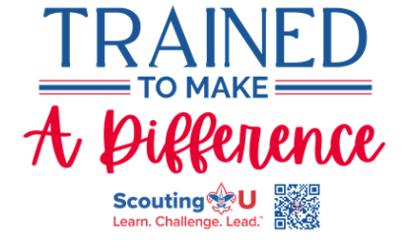.

UoE Guidebook for Scouting America Ships
A Tool to Help Your Ship and You Thrive
How to Use This Guidebook
This guidebook was created with busy Sea Scout Ship leadership in mind. It is intended to help the Ship Key 3—the Skipper, Ship Committee Chair, and Chartered Organization Representative—along with youth officers of the Quarterdeck and the Ship committee, use the Aloha Council Unit of Excellence (UoE) as both a program planning tool and a year-round checklist for delivering a high-quality, youth-led Sea Scouting experience.
The Unit of Excellence replaces Scouting America’s Journey to Excellence while maintaining a familiar structure. It is designed to help Ships plan, evaluate, and continuously improve their program in areas such as youth leadership, seamanship and maritime adventure, advancement, service, adult training, and long-term sustainability. The UoE framework recognizes that Sea Scout success is driven by youth leadership through the Quarterdeck and meaningful nautical experiences.
This guidebook draws from publications and resources available through Scouting America and Aloha Council and includes guidance on how to use those resources effectively. The Unit of Excellence incorporates and aligns many existing Scouting America programs and Sea Scout practices, some of which Ship leadership may not be fully familiar with. This guidebook explains what those programs are and how they connect to a successful Sea Scout Ship.
When used as intended, the information in this guidebook will help a Ship conduct an effective annual planning process, led by the Quarterdeck and supported by adult leaders, that prepares the Ship for a year of meaningful maritime adventure, leadership development, service, and fun.

This Guidebook Consists of (in Order)
- A summary sheet identifying a responsible youth officer or adult leader for each Unit of Excellence objective
- The 2026 Sea Scout Ship Unit of Excellence Scorecard, showing UoE objectives, measures, and performance levels
- The 2026 UoE Tracking Workbook/Spreadsheet, used as a planning checklist and progress-tracking tool
- Step-by-step guidance, presented in a suggested planning order, to help build a Sea Scout Ship program that delivers a high-quality maritime experience while aligning with Unit of Excellence objectives

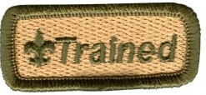
Adult leaders in units are considered “trained” and eligible to wear the official Trained emblem when they have completed Safeguarding Youth Training and the training courses outlined in the linked document below.
Listed below are a few Sea Scouting on-line training modules providing further information on the what and how of each UoE objective. (See Objective #12, Trained Leadership)
Sea Scouting Position Trained Requirements table-latest revision

Module SCO_602 – Planning Your Ships Program
Module SCO_620 – Planning A Long Cruise
Module SCO_621 – Executing A Long Cruise

Outdoor activities - SCO_800 - Hazardous Weather Training
Advancement Module SCO_605 – Sea Scout Advancement

Progress Record Sheets for:
- Scouter’s Training Award for Sea Scouting Leaders - latest revision
- Skipper's Key- latest revision
- Sea Scout Service Award
- Unit Leader Award of Merit – latest revision
Crew budgeting information
- Sea Scout Float Plan
- Unit Money-Earning Application

Leader Training
Leader training and recognition is extensively discussed in this guidebook and mentioned here. Providing leadership for Unit of Excellence objectives is an important part of having a successful unit. Please use the following summary sheet as a tool to guide the Ship adults in helping the Ship be the best it can be.

Sea Scout Ship Unit of Excellence Planning 2026 Summary Sheet
Ship:_____________________ District:____________________________
Unit of Excellence Overall Goal
- Bronze
- Silver
- Gold

This table lists all 14 UoE objectives in the order presented in the guidebook. For each objective list the responsible adult and circle the UoE goal the volunteer is helping the Ship achieve.
UoE Scoresheet Objective | # | Responsible Adult | Goal
 | 1 |  | B S G
 | 2 |  | B S G
 | 3 |  | B S G
 | 4 |  | B S G
 | 5 |  | B S G
 | 6 |  | B S G
 | 7 |  | B S G
 | 8 |  | B S G
 | 9 |  | B S G
 | 10 |  | B S G
 | 11 |  | B S G
 | 12 |  | B S G
 | 13 |  | B S G
 | 14 |  | B S G
 | 15 |  | B S G

____________________________ _________________
Skipper Date

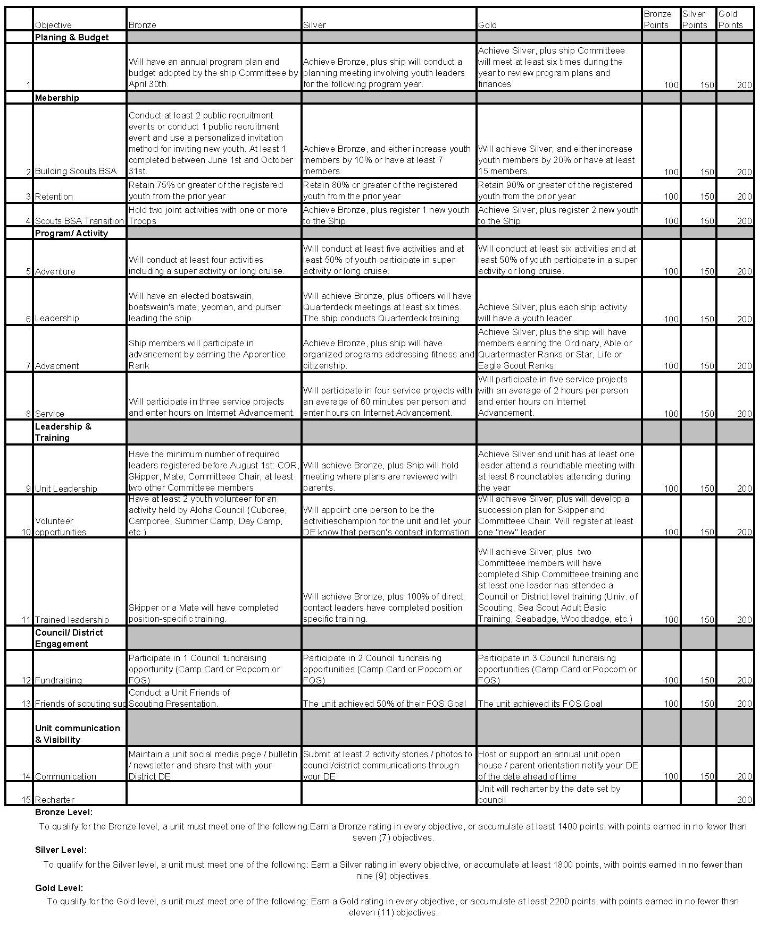Aloha Council’s Unit of Excellence
2026 Ship Planning, Performance, and Recognition
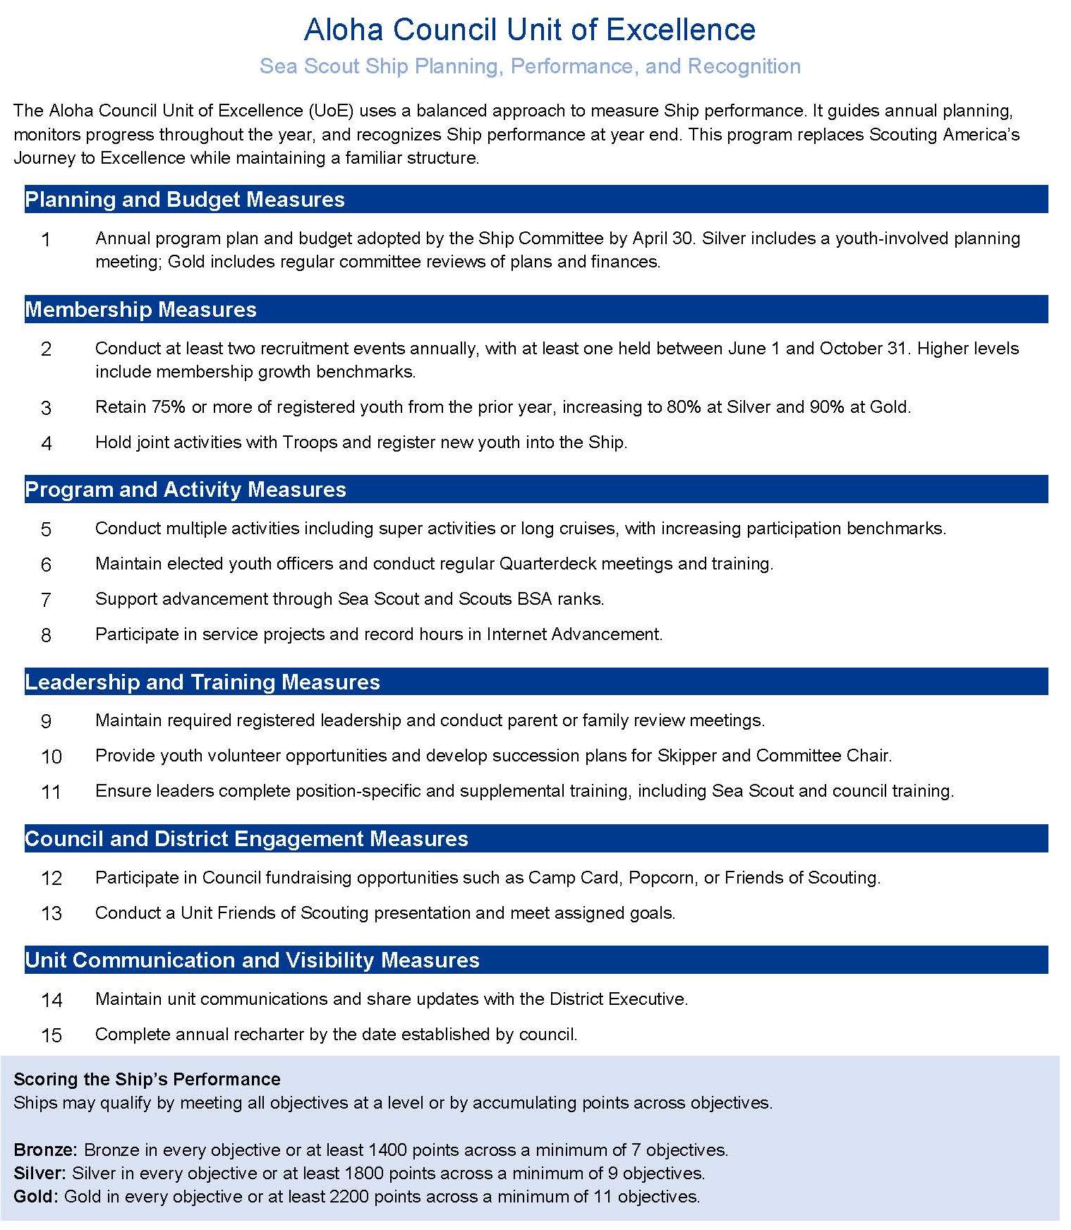
Planning for Success
Every Sea Scout Ship should have a regular and intentional planning process. A successful Ship is built through careful planning of cruises, super activities, training, advancement, service, and finances.
Planning should be led by the Quarterdeck, with guidance from the Skipper and committee. The format is flexible, but every Ship must have a written annual plan.
Key Ship leadership should be involved, including:
- Boatswain and Quarterdeck officers
- Skipper and Mates
- Ship Committee Chair and members

Commissioner Tip: Quarterdeck Leadership
What to look for:
Is the Quarterdeck actively leading Ship operations?
How to help:
Reinforce that Ship success depends on youth leadership through the Quarterdeck, supported—not replaced—by adults.

Commissioner Tip: Program Planning
What to look for:
Does the Ship have a clear annual cruise and activity plan?
How to help:
Encourage planning focused on seamanship, adventure, advancement, and safety, aligned with UoE objectives.

The Role of Commissioners
Ships are encouraged to involve their Unit Commissioner in the planning process. Commissioners help Ships interpret objectives and connect with council and district resources.
Commissioner Tip: Role of Commissioners
What to look for:
Are there District or Council Resources that would assist the Ship with their goals?
How to help:
Look for upcoming activities and events that align with the goals of the ship.

Understanding the Unit of Excellence Objectives
Ship objectives emphasize:
- Adventure and cruising
- Youth leadership through the Quarterdeck
- Advancement and seamanship
- Service and council engagement
- Trained adult leadership
Bronze, Silver, and Gold levels recognize increasing program depth and leadership maturity.

Commissioner Tip: Understanding UoE Objectives
What to look for:
Are leaders unsure how maritime activities align with UoE?
How to help:
Explain how cruising, training, and advancement naturally support multiple UoE objectives simultaneously.

Using the UoE Scorecard and Tracking Tools
The Crew Unit of Excellence Scorecard summarizes each objective and its expectations. Additional explanation is provided through council materials and scorecard guidance.
A tracking worksheet or spreadsheet is available to help troops:
- Record planned activities
- Track progress throughout the year
- Calculate points and recognition level
Using the tracking tool during the planning session helps ship leadership clearly see what actions are needed to reach Bronze, Silver, or Gold.
Commissioner Tip: Leadership Development
What to look for:
Are Quarterdeck or officer meetings happening regularly?
How to help:
Encourage consistent officer meetings and leadership training to support Silver and Gold level expectations.

Before the Planning Session Begins
Before holding your annual planning session, it is helpful to:
- Confirm the meeting location and participants
- Gather school vacation schedules and holiday calendars
- Review district and council event dates
- Decide how the program calendar will be displayed
- Ensure the meeting space allows for discussion and collaboration
Preparation helps make the planning session efficient and productive.
Commissioner Tip: Before the Planning Session
What to look for:
Is the budget driving the program instead of supporting it?
How to help:
Remind leaders: Plan the program first, then build the budget to support it.

Where to Start? Objective #1 – Calendar and Budget
Objective #1 provides the roadmap for Ship operations. The Quarterdeck plans the program first, followed by budgeting to support activities.
Bronze requires a published plan adopted by April 30. Silver and Gold levels build upon this with youth-led planning and regular committee reviews.
Commissioner Tip: Advancement and Training
What to look for:
Is advancement treated as optional or secondary?
How to help:
Connect Sea Scout ranks and certifications directly to leadership development and program quality.

Commissioner Tip: Adult Leadership
What to look for:
Are adult leaders trained for maritime operations?
How to help:
Encourage position-specific training, Sea Scout Adult Basic Training, and ongoing skills development.

Putting It All Together
The Unit of Excellence helps Ships:
- Deliver consistent, high-quality maritime programs
- Develop skilled youth leaders
- Retain members through meaningful adventure
- Strengthen connections to the council and community
Commissioner Tip: Putting It All Together
What to look for:
Is the Ship struggling with retention?
How to help:
Use UoE objectives to ensure a balanced mix of adventure, leadership, service, and advancement that keeps youth engaged.

Commissioner Reminder
The Unit of Excellence is most effective when it is used:
- Before the program year begins
- During the year to guide progress
- After the year to reflect and improve

Continued Training
Encourage Ship leadership - Quarterdeck officers and adult leaders alike - to pursue ongoing training throughout the year. Continued training supports safe maritime operations, strong youth leadership, and successful Ship programs, aligning directly with Unit of Excellence objectives.
Place District Roundtable and Sea Scout–specific training opportunities on the Ship planning calendar. Council and National Sea Scouting training events should also be identified and scheduled.

Adult Leader Training Awards – Sea Scouts
Sea Scout adult leaders are encouraged to work toward earning the Scouter’s Training Award for Sea Scouting, recognizing trained, engaged leaders who contribute to Ship success.
Current requirements include:
- Registration and required tenure as Skipper, Mate, or Committee Member
- Completion of Safeguarding Youth Training and Sea Scout position-specific training
- Active involvement in Ship planning and operations
- Participation in supplemental training opportunities
Leaders should support at least one Ship Unit of Excellence objective, such as advancement, seamanship training, service, or program planning.

Unit Leader Award of Merit – Skipper
Skippers may be nominated for the Unit Leader Award of Merit, recognizing outstanding Ship leadership and sustained program quality.
Eligibility includes:
- Current registration as Skipper
- Required tenure and training completion
- Demonstrated success in youth-led maritime programming and advancement

Maritime and Advanced Training
Adult leaders supporting Ship activities should pursue:
- Sea Scout Adult Basic Training
- Safety Afloat, Safe Swim Defense, and maritime safety training as applicable
For advanced leadership development, Wood Badge and Sea Badge are strongly encouraged. Training dates should be added to the Ship planning calendar and reviewed annually.

Putting It All Together (All Programs)
Ongoing training is essential to delivering a safe, engaging, and sustainable Scouting program. Units that prioritize leader development are better positioned to achieve Silver or Gold Unit of Excellence recognition and provide outstanding experiences for youth.

Outdoor Fun!
Unit of Excellence Objectives: Adventure, Seamanship, Program, and Service
Outdoor adventure and maritime experiences are the foundation of Sea Scouting. These activities should be planned and led by the Quarterdeck and intentionally aligned with Unit of Excellence (UoE) objectives.
Maritime Adventure and Cruises
Ships should plan a program that includes:
- Cruises and sailing activities
- Seamanship and nautical skills training
- Super activities or long-term cruises
- Waterfront or maritime events
Dates for cruises, training weekends, and council or national Sea Scout events should be placed on the Ship calendar.
Strong Ships offer regular maritime experiences that build skills, confidence, and youth leadership.

Ship Activities and Training Events
In addition to major cruises, Ships should plan regular activities such as:
- Skills instruction
- Safety and seamanship training
- Joint activities with other Ships
These activities support advancement, retention, and program quality.

Service Projects
Service remains a key component of Sea Scouting. Ships should plan multiple service projects, many of which may be maritime or conservation focused.
Examples include:
- Waterfront cleanups
- Support for maritime organizations
- Community or chartered organization service
All service hours must be recorded in Scoutbook Plus.
Increasing participation and leadership in service projects supports higher levels of Unit of Excellence recognition.

Coordinating Program and Service
Assign a Quarterdeck officer or adult leader to coordinate cruises, training, and service projects. This role supports:
- Program planning and execution
- Safety and compliance
- Tracking service and participation
Serving in this role reinforces youth leadership and supports adult leader recognition and training progress.

Putting It All Together
A well-planned maritime program helps Ships:
- Deliver meaningful adventure and seamanship training
- Develop strong youth leaders
- Retain members through exciting experiences
- Achieve higher Unit of Excellence recognition
Sea Scouting thrives on adventure - plan it well and sail often.

Recruiting & Building the Ship - UoE Objective #2
Ships should recruit youth interested in maritime adventure and leadership.
Recruiting opportunities may include:
- Waterfront events
- Sailing demonstrations
- Community outreach
- Joint events with other Ships or units
The Quarterdeck, supported by adult leaders, should lead recruiting efforts.

Transition & Program Continuity - UoE Objective #4
Ships may recruit:
- Scouts transitioning from Troops
- Venturers seeking maritime programs
- New youth from the community
Joint activities support smooth onboarding and retention.

Ship Planning and Budget - UoE Objective #1
The Quarterdeck should lead annual program planning, including:
- Cruises and training events
- Seamanship instruction
- Service and advancement activities
The Ship Committee should review plans and finances throughout the year.

Advancement, Seamanship & Service - UoE Objectives #5–#8
Ships demonstrate excellence by:
- Supporting Sea Scout advancement
- Offering regular maritime experiences
- Conducting service projects
All activities and service hours should be recorded in Scoutbook.

Retention Through Adventure & Leadership - UoE Objective #3
Retention in Sea Scouting is driven by:
- Quality maritime experiences
- Strong youth leadership
- A clear sense of purpose and belonging

Putting It All Together (All Programs)
Recruiting, planning, advancement, and retention are interconnected. Units that plan intentionally, empower youth leadership, and deliver exciting programs naturally achieve higher levels of Unit of Excellence recognition.

